Report of the Resident Scrutiny Panel – Rosebery Housing
Complaints Handling

- Introduction
Between early June and the end of September 2023, the Resident Scrutiny Panel (RSP)l undertook a Scrutiny of Rosebery’s Complaints Handling processes. The scope of this Scrutiny was:
- ‘Governance’ of processes, including signing off stages before escalation.
- Analysis of types of complaint. Comparison with national position.
- Timeliness of complaints handling. Compare with Policy and Complaints Handling Code.
- Escalation, frequency, and process.
- Ownership of complaints. Is this a feature or are complainants ‘passed around’?
- Compliance with the Complaints Handling Code.
- Percentage of Rosebery complaints upheld by the Housing Ombudsman Service. Comparison with national situation.
The panel considered that Complaints Handling should be a priority for scrutiny, as it has a significantly increased profile nationally, particularly with the strengthened role of the Housing Ombudsman Service, and it had also been some time since Complaints Handling had been looked at within Rosebery.
Resident Scrutiny itself is seen within in the Housing Sector as a key contributor to the resident holding to account the landlord body for its performance and delivering its purpose. The outcomes of Resident Scrutiny are intended to influence the business direction of the landlord body and, where appropriate, bring about improvements in its accountability and performance.
This report sets out the context for Complaints Handlining within the Association, how it relates to services generally. It describes the process that was followed by the Panel, the methods used to carry out the Scrutiny. The report then sets out the evidence gathered by those methods, and the findings. This is followed by the conclusions drawn and agreed upon from the evidence and recommendations that the Panel wish to make to the Association arising from those conclusions.
- Context of Complaints Handling within Rosebery
Effective Complaints Handling is a formal requirement of Rosebery, arising from the Regulatory Requirements monitored and assessed by the Regulator of Social Housing, and of the Housing Ombudsman Service, including through its Complaints Handling Code.
Beyond formal requirements, effective Complaints Handling is a matter of Good Practice for Housing Associations (indeed any organisation with customers) and provides an opportunity to put things right when matters are acknowledged as having gone wrong (perhaps with compensation), learning lessons from upheld complaints for service improvement, and enhancing customer satisfaction.
In this regard, effective Complaints Handling impacts on much of Rosebery’s landlord performance. This is why it is regarded as a central feature of a landlord body’s operation to consider.
- Process followed by the scrutiny (methods).
The following methods were used to undertake the Scrutiny.
Method | Description
Call for Documents | Requested and considered Rosebery’s documents relating to complaints handling.
Staff Presentation | Presentation from Business Analyst on Town & Country Housing (TCH) (Rosebery) Health Check 12 Month Period (2022) held on 15th May 2023.
Staff Briefing | Presentation from Customer Experience Manager and Senior Customer Experience Officer on Rosebery Policy and Procedure on Complaints Handling held on 20th June 2023.
1-2-1 Meeting with Rosebery Residents | Discussion with residents with completed complaints regarding their experience held on 3rd July 2023.
Staff Interviews | 21st July 2023  Customer Experience Manager  Head of Housing and Customer Experience  28th July 2023  Senior Customer Experience Officer  The purpose of these interviews was to gain an understanding on their roles; including their opinions on their role, policy and procedures and their involvement with handling Stage 1 and Stage 2 complaints.
Housing Ombudsman Presentation | A presentation and Q&A held with Compliance and Systemic Investigation Manager on 1st August 2023.
Questionnaire Survey on Residents Completed Complaints during 2022 to present | To gain views on their experiences.

The Scrutiny Panel would like to thank the following for their invaluable contribution to the scrutiny process:
- Rosebery residents who agreed to be interviewed
- Rosebery Data Analyst
- Rosebery Customer Experience Manager
- Rosebery Head of Housing and Customer Experience
- Rosebery Senior Customer Experience Officer
- Housing Ombudsman Compliance and Systemic Investigation Manager
We would like to extend a special thank you to the Customer Engagement Officer for her valuable support and dedication to the panel.
This process would not have been possible without the expert guidance from the Independent Advisor.
- Findings
  - Call for Documents

The following documents were called for to facilitate the discovery stage.

Table 1 – Call for Documents List

No | Item
1 | Rosebery’s Annual Complaints Report - 2020/21
2 | The Housing Ombudsman’s Complaint Handling Code - 1 April 2022
3 | Housing Ombudsman Complaint Handling Code - Rosebery’s Self-Assessment - September 2022
4 | Making Scrutiny Work - Independent Advisor - June 2023
5 | Outcome of Resident Scrutiny Panel Meeting - 8 June 2023
6 | Peabody/TCH Customer Complaints Policy (Legacy Rosebery) - Effective from 4 April 2023
7 | Complaint Data Summary of Complaints During 2022/23 Financial Year

The following were highlighted from the documents we considered: -
The Rosebery’s Annual Complaints Report - 2020/21 - concluded with key priorities for improvements during 2020/21 which were: -
Customer Insight - improve the way Rosebery utilise lessons learnt from complaints to transform services and improve customer experience. A new process has recently been introduced that all closed cases require an ‘overview’ report, detailing complaint outcome(s) and lessons learnt. Once every quarter these cases are reviewed to understand if there are any themes/root causes that require service improvements.

Staff Training and Development - ensure ongoing complaints training opportunities are provided for all customer-facing staff so they feel empowered to reduce complaint volumes and encourage early resolution.
Performance Management - embedding the consistent use of our Customer Relationship Management (CRM), across the organisation, so it is a robust tool to support the monitoring of staff activities, to achieve consistent performance in meeting our service standards and high performing culture.
The Housing Ombudsman’s Complaint Handling Code - 1 April 2022 - enabled us to understand the national requirements for complaints handling in Social Housing. Also Housing Ombudsman Complaint Handling Code - Rosebery’s Self-Assessment - September 2022 which found that complete compliance with the code existed.
Making Scrutiny Work - Michael Guest - June 2023 - an explanation on effective resident scrutiny.
Outcome of Resident Scrutiny Panel Meeting - 8 June 2023 - decided the scope and methods to be used in the scrutiny.
Peabody/TCH Customer Complaints Policy (Legacy Rosebery) - Effective from 4 April 2023 - informed us of the current complaints policy followed by Rosebery following the merger with TCH.
Complaint Data Summary of Complaints During 2022/23 Financial Year - The details of this are set out in Section 4.8 and in Figure 1 & Figure 2.
4.2 Staff Presentation - Business Analyst - TCH (Rosebery Health Check 12 Month Period
As part of the scoping exercise that resulted in complaints been chosen as the subject for scrutiny, the Business Analyst gave the whole scrutiny panel an analysis of data relating to Rosebery’s overall performance, including the high level of complaints regarding communication.
Although this predated the start of the scrutiny it provided valuable evidence to support the process.
Set out below are key details from the presentation shared with us: -
Key Performance Indicators (KPIs) Complaints - During 2022 to 23 - Complaints raised at Stage 1 were 90 and 17 complaints raised at Stage 2.
During May 2022, a number of spikes occurred when the stamp duty relief was set up by the government for people were looking to buy a house. This affected when Rosebery offered leasehold tenancies and shared ownership properties. The team were inundated with enquiries from Solicitors and essentially the number of complaints increased, and Rosebery was unable to keep up with demand at the time.
The second spike with an increase in general complaints due to a fall in service to tenants including issues surrounding damp and mould. Damp and mould being prominent in the news and social media at the time, as well as being the target of advertising on how to claim compensation.
Cladding does not affect the complaints figures as most of Rosebery’s housing stock comprises of houses or three storey blocks of flats, therefore most of the properties do not have any cladding.
The Housing Ombudsman have been very proactive in promoting how residents should complain, campaigning and raising awareness about the service that they offer including service failures. In the current culture more people are happier to complain.

Figure 1 below shows the breakdown into the number of complaints opened by subject matters, that were raised during April 2022 to March 2023: -

Figure 1 – Number of complaints opened by subject matters raised

4.3 Staff Briefing - Customer Experience Manager and Senior Customer Experience Officer
It was confirmed that there are two formal stages in Rosebery’s Complaints Policy and procedure. In addition, a quick resolution route opportunity is also available.
The definition for ‘what is a complaint’ adopted by Rosebery is the same as stated in The Housing Ombudsman Complaints Handling Code: ‘an expression of dissatisfaction, however made, about the standard of service, actions, or lack of action by the organisation, its own staff, or those acting on its behalf, affecting an individual resident or group of residents’.
For example:
- Action or lack of action in response to a service request
- Poor quality service
- The behaviour of Rosebery staff or contractors working on our behalf
- Failure to follow an approved Rosebery policy or procedure.

This is a requirement across the housing sector where all housing providers must comply. The Housing Ombudsman Complaint Handling Code.
An overview of Rosebery’s complaints Policy:
Stage 1 Complaint is acknowledged within two working days and handed to the complaint’s handler.
Complaints can be made in writing, by email, online, over the telephone or face to face with a member of our staff.
- A quick resolution route can be decided within three working days but still dealt with and logged as a complaint.
- Communication during this process is normally done through email and telephone.
- It may not fix the problem but instead offers a resolution with an agreed plan and the matter is then closed.
- If the complainant is not happy, they can still escalate it to a Stage 1 Complaint.
- If the complaint cannot be handled within 3 working days, the complainant will be informed of the options for escalating to a Stage 1 Complaint or leaving it as a quick resolution.
- If the complainant decides to escalate to a Stage 1 Complaint, they will be contacted within two working days.
- All Stage 1 Complaints are normally dealt with in ten working days once it has been allocated to a lead handler or the Senior Customer Experience Officer, who are encouraged to make contact within 3 working days to gain clarification and more understanding on what resolution the complainant is looking for and what can be done.
- A complaint can be extended to a further 10 working days, which will be dealt with by a Senior Customer Experience Officer who will handle expectations, investigations and speak to staff involved.
- It is useful to have an early dialogue with clear expectations so the complaint can be resolved quickly with a successful outcome which will be reviewed.
- A letter is sent out with the decision, resolution, or outcome, also indicating the complaint is closed.
- If the complainant is not happy with the decision. A letter is sent with a clear action plan including dates with a response provided within 28 days with a resolution and/or compensation.
- If a decision is made that Rosebery are not responsible it will be clearly set out using a template format for consistency in case escalated to Stage 2 Complaint.
It was stated that over 70% were resolved last year (2022) at Stage 1.
Stage 2 Complaint - If a complainant is dissatisfied with the way that the complaint was dealt with, either not in a fair manner or dissatisfied with the response, they can request a review of their complaint case.
- All Stage 2 complaints will be acknowledged within 2 working days.
- Dealt with by a manager who has no previous involvement, and a response is given within 10 working days.
- The manager will contact the complainant to find out why they were not happy with the Stage 1 response.
- The complainant can take the complaint to The Housing Ombudsman if not satisfied with the outcome.
We learned that Rosebery has seen different themes throughout recent years including relating to Covid and the stamp duty holiday with Rosebery not meeting demand with responses to providing information or dealing with enquiries.
The last financial year (2022/23) had seen 21% of complaints received related to communications issues, followed by services provided by T Brown and Rosebery Repairs In-House Team at 13%. In particular, content and timeliness of response.
Complaints can be made by telephone, a visit to the office, email, social media channels etc. Rosebery communicates during the process with the complainant through telephone or email with final responses to all formal complaints communicated in writing by letter.
Residents who are not satisfied with written response to Stage 2 from Rosebery are advised that they have the right to escalate their complaint to the Housing Ombudsman.

We were provided with data from the Customer Experience Manager setting out types of complaints received as indicated in below Figure 2.
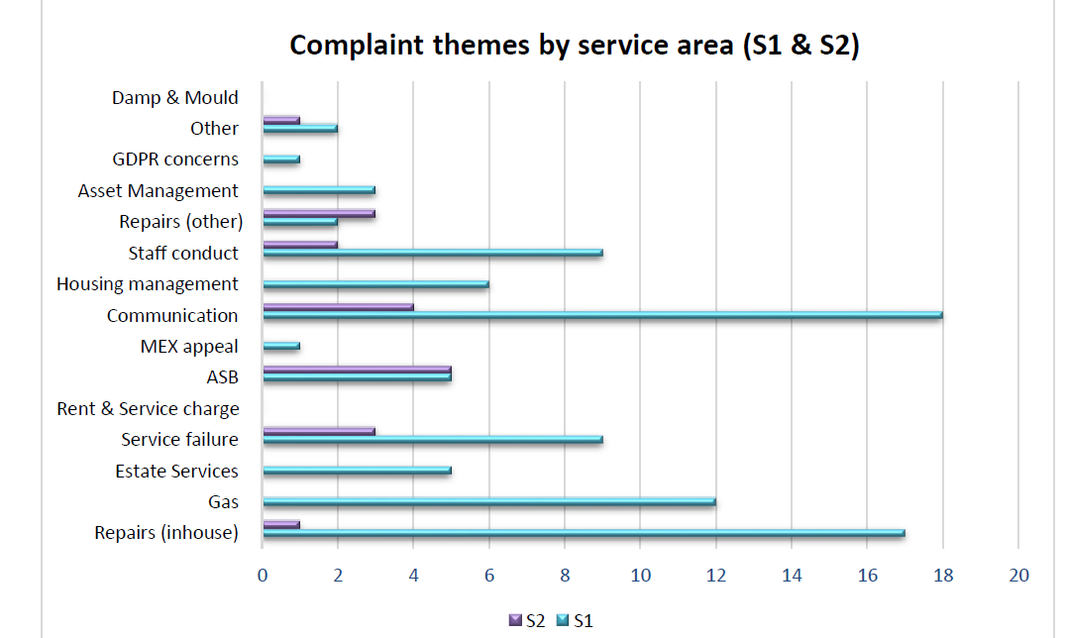

Figure 2 - Complaint Themes by Service Area (S1 &S2)

4.4 1-2-1 Meeting with Rosebery Residents - 3 July 2023
It was beneficial to see from the customer’s perspective of those who had experience with going through Rosebery’s complaints process and closed within the last 12 months.
The five interviewees represented a cross section of Rosebery residents, comprising of two shared owners, two general needs and one leaseholder.
In general, residents were not happy with the outcome of their complaint, with the prominent theme being poor communication.
Residents mentioned that there is a lack of consistency with the way Rosebery handled their complaint, as they felt it was confusing with too many staff involved in the process. There was often difficulty in identifying who was dealing with the complaint and establishing accountability.
During the interviews it was mentioned that it was difficult to make a complaint online. The interviewees knew of problems using the Rosebery website and portal.
Using this information, the RSP quickly examined the Rosebery website and discovered that some HTML (Hypertext Markup Language) hyperlinks are missing. This denies the residents a route to making a complaint via the website. With this knowledge gained by the RSP, the website can be easily repaired and made functional to benefit residents wishing to make a complaint. Rosebery failed to capture this knowledge.
There was a mixed awareness of the complaints policy and processes, including the availability of accessing the Housing Ombudsman.
Details of the interviews are shown Appendix I - Table 2.
4.5 Staff Interviews - 21 & 27 July 2023
Having met with the Head of Housing and Customer Experience, Customer Experience Manager and Senior Customer Experience Officer, it offered the opportunity to ask and compare a set of questions about their roles, and specifically focusing on the area of Customer Complaints, a valuable insight into the operational mechanisms of how the team functioned was gleaned.
Details of the interviews are shown Appendix II Table 3.
4.6 Housing Ombudsman Presentation - 01 August 2023
The Compliance and Systemic Investigation Manager at the Housing Ombudsman gave a presentation to the RSP on 1st August 2023 on their role within the Insight and Development Team, who take on individual investigations and determinations to look at themes, trends and patterns relating to dispute resolutions. The results are shared, from which the Housing Sector can learn and benefit from.
The manager is responsible for routine monitoring of compliance with the Complaints Handling Code and is soon to take on the Monitoring Team. Responsibilities also include reviewing Provider’s Self Assessments and their policies to make sure they are Code compliant.
The team have to the authority to issue Type 3 Complaint Handling Failure Orders and make sure they are complied with.
Appendix III sets out the presentation slides and in Table 4 the questions and answers arising.

4.7 Questionnaire Survey on Residents Completed Complaints (2022 to present)
The panel planned to run a focus group with residents who had completed a complaints case within the last 12 months. Unfortunately, there were not enough residents who volunteered. Therefore, it was decided to undertake a remote questionnaire survey via text message and email to 30 completed complainants. In total 4 responded (15%) which does not represent a viable sample set. It was determined not to use the data from this survey.
4.8 Data Provided by the Senior Customer Experience Officer
The panel received and considered a summary of complaints during the 2022/23 financial year and the current period up until the end of June 2023. Full details for which can be obtained from the Customer Engagement Officer.
Whilst the proportion of Complaints that were escalated to Stage 2 remained fairly low, when compared to overall complaints received, there is however a significant (90%) increase in the volume of complaints that were escalated in 2021/22 when compared to the previous year, and whilst the volume of Stage 2 complaints reduced in 2022/23 it was still over 54% higher than during the peak pandemic year of 2020/21.

Table 5 - Partial Analysis on Data Provided
PARAMETER | 2020/21 | 2021/22 | 2022/23 | 2021-22  %Change | 2022-23 %Change
Overall Complaints | 125 | 145 | 127 | +16.00% | -12.41%
Quick Response | 19 | 16 | 20 | -15.79% | +25.00%
Stage 1 | 95 | 108 | 90 | +13.68% | -16.66%
Stage 2 | 11 | 21 | 17 | +90.90% | -19.05%
Escalated to HOS | 1 | 4 | 2 | +300.00% | -50.00%

4.9 Additional Evidence

Figures 3.1 and 3.2 below set out benchmarking data from Rosebery’s piloting of Tenants Satisfaction Measures (TSM) over a 6-month period regarding volume of complaints and satisfaction with complaints handling. This has been used as a substitute for fuller and more comprehensive Benchmarking such as from Housemark.
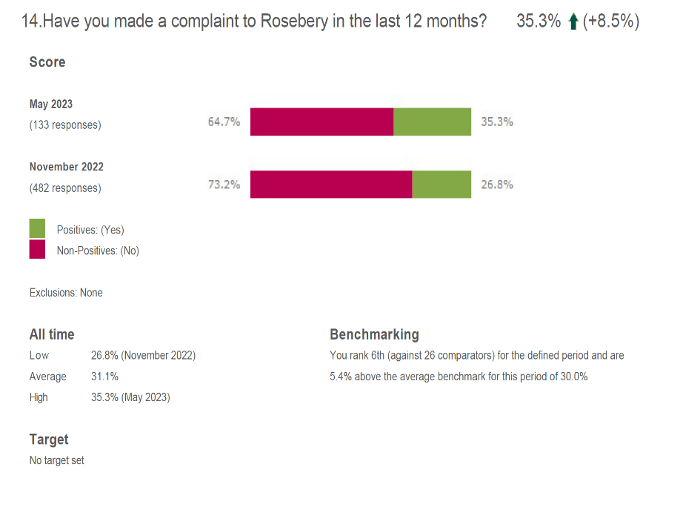

Figure 3.1- Rosebery TSM Survey November 2022 - May 2023
Figure 3.2 - Rosebery TSM Survey November 2022 - May 2023
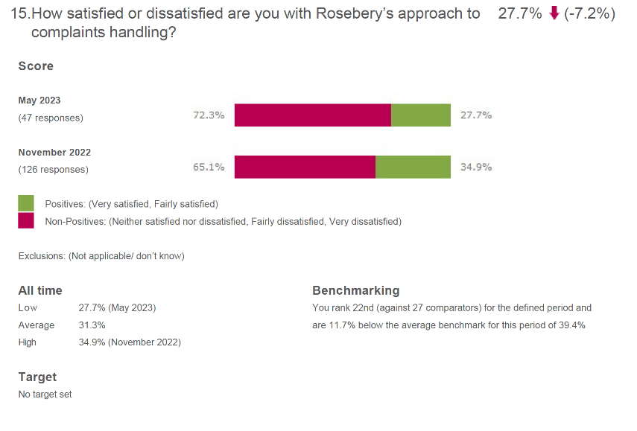
5. Conclusions
5.1 Governance of processes, including signing off stages before escalation
Arising from the staff interviews, there was evidence of overall parity between the interviewees with regards to governance and adherence with the complaints processes. To support this, Rosebery’s Annual Complaints Report - 2020/21 and 2022/23 when matched against the Housing Ombudsman Complaints Handling Code were found to comply.

We were assured from the Annual Report 2020/21, that work to improve the way Rosebery utilise lessons learnt from complaints to transform services and improve customer experience, will be undertaken. Also, that a new process has been introduced to ensure all closed cases require an ‘overview’ report detailing complaint outcome and lessons learnt. Once every quarter the cases are reviewed to understand if there are any themes or root causes that require service improvements. It will take time to see benefits of these.

The RSP has had sight of the evidence to support that these reports are being collated and reviewed. However, the last meeting evidence was dated September 2022. More recent examples cannot be provided due the recent merger with TCH, and no further meetings have been held this year. The lack of data from 2023 seems to indicate this. However, the RSP have been advised that a review of overview reports will be a standing agenda item at the organisation management meetings, were due to start in August 2023 on a monthly basis. The RSP noted there is almost a 12-month gap where a significant amount of time has been lost in potential lessons learnt.

It is evident from the staff interviews that plans are in place for staff training in the near future. However, no evidence has been provided on when training will take place.

Rosebery offers a wide range of ways to make a complaint but on their website, it is not clear on where residents can send a complaint under the section ‘How can I make a complaint?’ for example who do you send an email to, sending them through to where, writing to whom or discuss with which member of staff. Also making a complaint online, through the My Rosebery Account portal is difficult to access as it buried under multiple sub menus.

It is apparent from the ‘How can I make a complaint?’ section within the website that the Rosebery website is not monitored as HTML hyperlinks are obviously missing. It is clear from the 1-2-1 interviews that complainants knew the website was not functional, but this knowledge was not captured by Rosebery. This contrasts with the Housing Ombudsman Spotlight report from May 2023 focussed on Knowledge and Information Management which finds the first lesson “is for landlords to squeeze every ounce of insight on information management from their complaints and to do so in a structured and appropriate way”. There is no function available to interact with the website to enable the user to directly make a complaint.

We could not find an option to access a complaints form or through My Rosebery account, these corroborates with the evidence given at the 1-2-1 interviews with the complainants. In addition, we had the same experience when testing. We also carried out the same experiment on the TCH website and find it more advanced, intuitive and user friendly.

We concluded that a lack of ownership was a common area of concern evidenced by the complainants in the 1-2-1 interviews.

5.2 Analysis of types of complaint and Comparison with national position
Of particular note was the apparent resolution of quick resolutions, meaning a matter that does not escalate to a formal complaint. Presumably meaning a satisfied customer and less time consuming for Rosebery. In 2022/23 no quick resolutions were escalated to a Stage 1 and so far in the current year only one has. However, it should be noted that residents have the right to escalate to Stage 1. During 2022/23 period 90 complaints received directly at Stage 1 of which 17 escalated to Stage 2.
According to the data from benchmarking out of 26 comparable housing providers Rosebery was ranked as 6th in response to (Have you made a complaint to Rosebery in the last 12 months?) this represents an increase of 8.5% between November 2022 and May 2023. This may indicate that it is relatively easy to make a complaint to Rosebery contrary to the view of talking with residents and testing the website.
Regarding satisfaction with Rosebery approach to complaints handling the benchmark data places Rosebery 22nd out of 27 comparable housing providers which is consistent with 1-2-1 interviews held with residents, although it is acknowledged this is a small sample.
This benchmarking data comes from Rosebery’s piloting of Tenants Satisfaction Measures (TSM) over a 6-month period.
5.3 Timeliness of Complaints Handling. Compare with Policy and Complaints Handling Code
During 2022/23 the average response time for Stage 1 is 13.4 days and for Stage 2 it is 12.9 days. So far first quarter this year is at 10 days for Stage 1 and 11.4 days for Stage 2. This means the complaints response time are within target 63% in 2022/23 and 85% for the first quarter this year.
Rosebery’s current response time is within 10 working days whereas the Housing Ombudsman Complaints Handling Code requires no more than 20 working days.
Given that the average response times for both Stages 1 and 2 exceeded on average the 10 working days window but do fall well within the Housing Ombudsman guideline of 20 days, might it be prudent to ‘loosen’ Rosebery/TCH response time to be in line with the Housing Ombudsman, thus reinstating that all responses are well within a timely manner. However internally, still try and aim for 10 days, thus maintaining the ‘pace’ of work previously seen.
The suggested lack of ownership and number of staff involved in the complaints process exacerbated the perception of complainants at the 1-2-1 residents’ interviews regarding timeliness with responses.
5.4 Escalation, Frequency and Process
A possible strength found was the level of early resolution of complaints (i.e., not escalated to Stage 1) which was consistent over the two years.
Overall, complaints are showing a downward trend in the volume received from 2022/23 when compared with 2021/22, are broadly back in line with the 2020/21 figures.
It is not transparent why there was a 90% jump in Stage 2 cases, between 2020/21- 2022/22, and whilst the figure came down in 2022/23, still remains 54% higher than 2020/21, which was during the peak Covid-19 period.
However, during May 2022, practically all covid restrictions had been lifted, and daily life returning to normal. Analysis of the data indicates the lead reasons for Stage 2 complaints were relating to ‘Communication’ and ‘Staff Conduct’. As this includes aspects of services contracted out it is not clear whether this relates to Rosebery staff or 3rd party contractors.
5.5 Ownership of complaints. Is this a feature or are complainants ‘passed around’?
In reference to 5.3, the suggested lack of ownership and number of staff involved in the complaints process exacerbated the perception of complainants at the 1-2-1 residents’ interviews regarding timeliness with responses.
5.6 Compliance with the Complaints Handling Code
Rosebery’s Self-Assessment - September 2022 is found to be in full compliance with the existing code.
5.7 Percentage of Rosebery complaints upheld by the Housing Ombudsman Service. Comparison with national situation
In the periods scrutinised no complaints considered by the Housing Ombudsman were upheld.

Due to the Housing Ombudsman’s backlog in determining complaints, no determinations were made of complaints escalated during the period under scrutiny. Two complaints were escalated to the Housing Ombudsman, but no decision was reached by the Housing Ombudsman within the period.

The national situation as shown in the Housing Ombudsman annual report and accounts is also published after a delay. The 2021-22 report was published in November 2022. It is worthwhile scrutinising the previous period to gain an insight into Rosebery’s comparative performance.

A decision outcome from an enquiry in 2021/2022 indicated that no maladministration had been found from Rosebery. Prior cases indicate that around one quarter are upheld.

This compares favourably with the national situation in the same period when 48% of determined cases were upheld (Housing Ombudsman performance report 2021-2022). Also in prior years: 2020/2021 49% and 2019/2020 41%.

6. Recommendations
6.1 The RSP supports Rosebery’s plans to be the same as with TCH the complaints target response time (20 working days).
6.2 That Rosebery review and improve the Complaints aspect of the Website to make it easier to use, be consistent with TCH website and remove errors that are currently present.
6.3 Include point on aspects of services contracted out it is not clear whether this relates to Rosebery staff or contractors. Where complaints have been levelled at staff, further clarification needs to be sought about the types of service that were being provided, that resulted in a complaint aimed at personnel connected to the service, and whether the complaints were levelled at Rosebery (TCH) staff, or third party contractor staff, which still had the net effect of Rosebery (TCH) taking the blame.
6.4 Rosebery adopts the lessons learned from the Housing Ombudsman's report of May 2023 - Spotlight on: Knowledge and Information Management, especially "for landlords to squeeze every ounce of insight on information management from their complaints and to do so in a structured and appropriate way".
6.5 Rosebery provides easily accessible analogue alternatives (e.g. telephone contact, paper based forms) to digital routes for making complaints to avoid a digital division.
List of Supporting Evidence and Appendices
- Table 1 - Call for Documents List
2. Figure 1 - Number of complaints opened by subject raised during April 2022 to March 2023
3. Appendix I - Table 2 - 1-2-1 Meetings with Rosebery Residents - 3 July 2023
4. Appendix II - Table 3 - Rosebery Staff Interviews - 21 & 28 July 2023
5. Appendix III - Table 4 - Housing Ombudsman Presentation and Table 4 Q&A Resident Scrutiny Panel - 01 August 2023
6. Table 5 - Partial Analysis on Data Provided
7. Figure 2 - Complaint Themes by Service Area (S1&S2)
8. Figure 3.1 - Rosebery TSM Survey November 2022 - May 2023 - Question 14
9. Figure 3.2 - Rosebery TSM Survey November 2022 - May 2023 - Question 15

