Sounding Board

Q3 Survey Report
December 2020

Prepared by:

Theo Scott
Customer Experience Team Leader
1.0 Summary

- In October 2019, Rosebery launched a new Sounding Board, made up of residents that indicated that they are happy to engage with Rosebery by using digital channels, such as emails and SMS texts. The Sounding Board offered a unique opportunity to engage with a wider and more diverse range of residents in a systematic way.
- Since the launch of the Sounding Board, two surveys have been carried out. The first survey was completed in November 2019 and the second in October 2020.
- For the second survey, we introduced a suite of ‘tracker’ questions that will be used on every survey along with a number of ‘topical’ questions to gain views.
- In November 2020, we distributed the third survey and the ‘topical’ questions on this occasion focused on:
- Resident Involvement
- Digital Engagement
- Methodology

- The total number of residents invited to take part in the third survey was 1,981. This was an increase of 5.48% compared to the second survey. Members were also informed that all completed questionnaires would be entered into a prize draw.

- On 19 November an email, including a digital link, to complete the online questionnaire, was sent to our Sounding Board members. The deadline for completion was 1 December.
- During this time one reminder email was sent to all non-respondents, on 26 November.
- In total 201 residents completed the online questionnaire, which represented a response rate of 10.14%. The responses received were very encouraging and represented the highest response rate since the launch of the Sounding Board.

- Questionnaire Design

- The questionnaire included six ‘tracker’ questions, designed by Rosebery. These will allow us to monitor how well we are doing and where improvements need to be made over time.
- The responses to the ‘topical’ questions will primary be used to help with our planning for key services issues throughout the year. These will vary depending on what the key issues are at the time of each survey.
- The questionnaire also included some questions from the new standardised STAR survey developed by Housemark.
- Reporting

- The results have been analysed and where appropriate these results have been included in the report.
- Although the response rate was very encouraging, due
to the total number of residents that were invited to take part statistically the responses represented a low return.
- It is therefore vital that results with low bases are treated with caution, as each individual response has a large impact on the overall score.

5.0 Sounding Board – tracker questions

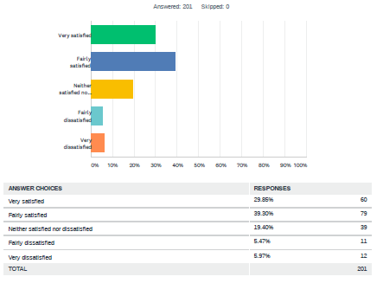
Q1. In general, how satisfied or dissatisfied are you with the way we keep you informed about our services?
Tracker satisfaction - direction of travel: No change

- Overall, the majority of respondents (69.15%) are satisfied in the way Rosebery keeps them informed about our services. This figure has remained static compared to the last survey completed in October 2020.
- 19.40% gave a neutral response stating they were neither satisfied nor dissatisfied. This figure is slightly gone down by 4.43%.
- Overall 11.44% were dissatisfied with 5.97% being very dissatisfied. This is up by 17.09% compared to the last survey.

Q2. – When you last contacted Rosebery, how easy was it to find someone who could deal with your enquiry?
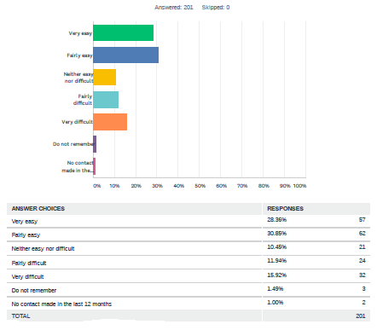
Tracker satisfaction - direction of travel: no change

- Overall, the majority of respondents (59.21%) found it easy to find someone who could deal with their enquiry when they last contacted Rosebery. However, this represents a decline of 10.28% compared to the last survey.
- 10.45%, expressed a neutral view, stating that it was neither easy or difficult. This remains static compared to the last survey.
- Overall 27.86%, found it difficult to find the right person to deal with their enquiry, with 15.92% finding it very difficult. This is up by 21.13% compared to the last survey.
- Whilst the trend is slightly down from last time, we have to consider that the sample size was relatively small. Given these marginal changes and the larger number of respondents for this survey, there is no overall change in customer perception.

Q3. – In general, do you think Rosebery’s services are getting better, staying the same or getting worse?

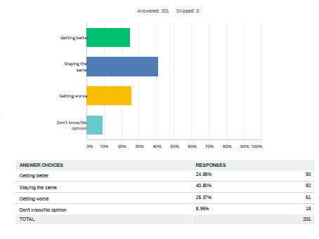
Tracker satisfaction - direction of travel: no change

- Just under a quarter of respondents (24.88%) thought Rosebery’s are getting better.
- 40.80% of respondents believe it’s staying the same, this is slightly up by 0.50% compared to the last survey. 25.37% feel it is getting worse. This is also slightly up by 5.44%.
- Given these marginal changes and most respondents view staying the same, it is positive to note that services are not getting worse, given the fact that the majority of Rosebery staff are now working from home due to the COVID-19 restrictions.
- 8.96% did not know or offered no opinion.

Q4. – To what extent do you agree or disagree with the statement, “my landlord listens to residents’ views and acts on them”

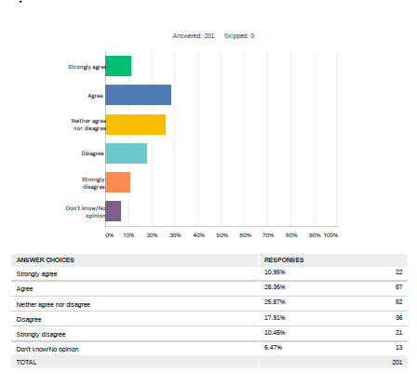
Tracker satisfaction - direction of travel: no change

- Overall, 39.31% of respondents, agreed with the statement, that “My landlord listens to residents views and acts on them”, with 10.95% of respondents strongly agreeing with this statement. This is slightly down from the last survey by 7.14%
- 25.87% neither agreed nor disagreed with this statement. This is slightly up from the last survey, by 7.87%
- Overall, 28.36% disagreed with this statement and 10.45%, strongly disagreed. This is also slightly up by 5.03%
- Given these marginal changes and the larger number of respondents for this survey, there is no significant change in customer perception.

Q5. “Overall, taking everything into account, to what extent do you agree or disagree with the statement, Rosebery services represent high quality”

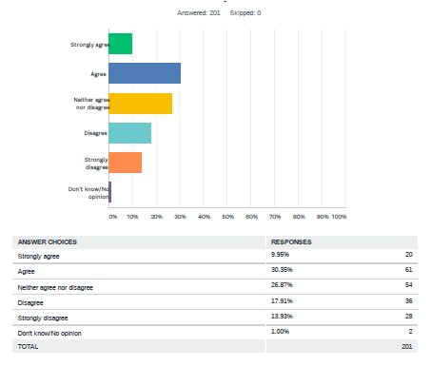
Tracker satisfaction - direction of travel: no change

- 40.30% of all respondents agreed with the statement “Rosebery’s services represent high quality”, 9.95 % strongly agreeing with this statement. Overall, this is slightly down by 12.39% compared to the last survey.
- 26.87% gave a neutral response stating that they were neither satisfied nor dissatisfied. This is slightly up by 11.95%
- 31.84% disagreed with this statement, with 13.93% expressing a strong disagreement. Overall, this is slightly up by 13.71%
- Given these marginal changes and the larger number of respondents for this survey, there is no significant change in customer perception.

Q6. Overall, taking everything into account, to what extent do you agree or disagree with the statement “Rosebery services represent value for money”

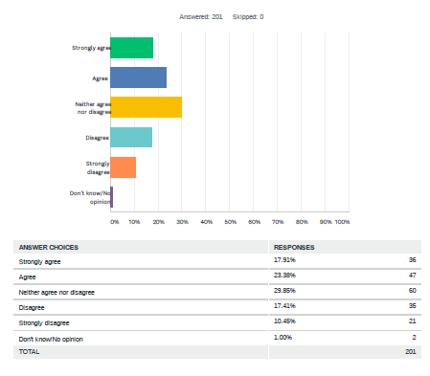
Tracker satisfaction - direction of travel: No change

- Overall, just under half of all respondents (41.29%), agreed with the statement that “Rosebery’s services represent value for money, with 17.91%, strongly agreeing with this statement. This is up by 5.35% compared to the last survey.
- 29.85% gave a neutral response stating they neither agreed or disagreed with this statement. This is slightly up by 2.93%
- Overall 27.86% disagreed with 10.45% strongly disagreeing with this statement. This is up by 26.59%
- Only 1% of respondents did not know or offered no opinion. This is down by 50%.

Topical questions – ‘Resident Involvement/Digital Engagement’

Resident Involvement is a key focus for Rosebery and it’s the responsibility of all staff to support and encourage your involvement. By listening to you, we carry on delivering the services that work well whilst working with you to review the services that need to improve.

The feedback received from these ‘topical’ questions will help us to review our Customer Engagement strategy and improve the opportunities that are available to you to give you a say in how services are shaped and delivered. At the same time, we are also looking to make better use of digital technology, so we can make it easier for everyone to get involved.

The feedback received to these questions are listed below:

Q7. What could Rosebery do to encourage more residents to get involved in decisions to help improve service delivery?

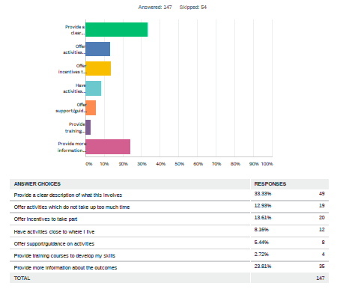

Q8. Where do you find information about resident involvement opportunities?

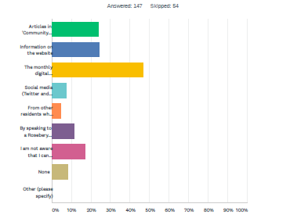

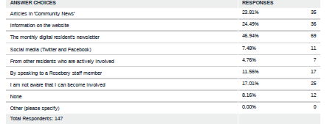

Q9. How could Rosebery improve communications about resident involvement?
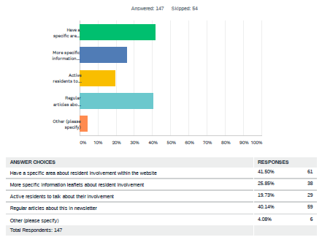

Q10. It’s easy to ‘get involved’ and we offer several opportunities. Let us know the options you feel comfortable with.

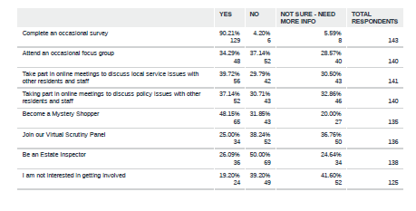

Q11. Do you have access to your own digital device and Internet access at home?

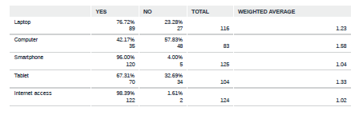

Q.12 How do you rate your own digital skills?

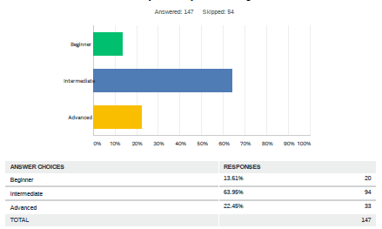

Q13. What digital method of communication do you prefer using when contacting Rosebery?

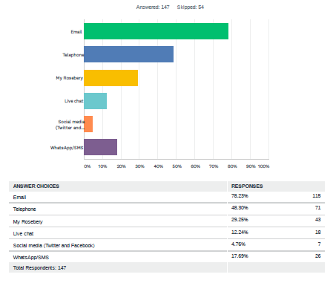

- What next?

We have found the feedback received very useful. The information will be used to help us review and develop our revised resident involvement and digital engagement strategies aimed at encouraging and supporting more residents to get involved with Rosebery. The strategies will be presented to Rosebery’s Board in May 2021.

Between now and then we will be contacting all residents that indicated they are interested in being involved so we can understand what opportunities are best suited for them and gain their views on the potential changes that we may introduce.

