Mystery Shopping Report

Service Area:
Customer touch points

Month: June 2019

Author:
Theo Scott
Customer Experience Team Leader

Background

Rosebery Housing Association is committed to continuous appraisal of its services. One of the activities used by Rosebery to track customer satisfaction and test the standards of our customer-facing services over time, is our mystery shopping programme. For this exercise, our shoppers inspected our customer touch points.

Our shoppers decided to look at this area to note improvements made since this service area was first shopped in June 2018. It was also an opportunity to test the upgraded tenant portal ‘My Rosebery’, to understand what experience this now offers, in terms of ‘ease of use’ and functionality, as this was not included in the first exercise. The other touch points tested in this exercise were letters, emails and home/office visits.

To protect the integrity of this exercise, Team Leaders from the respective service teams were given no prior notice a mystery shopping exercise was being carried out, that will include their service areas.

Introduction

All shoppers were required to attend a training session on Wednesday 29 May 2019. In total four residents agreed to take part in this exercise.

All mystery shoppers were asked to complete standard online feedback forms to record their experiences. Each shopper was asked to complete a maximum of 10 shops and record their feedback once they have completed each shop. To compare and quantify their experiences each shopper was given specific questions to ask from a list of pre-prepared scenarios/enquiries that could be used. Shoppers were also advised on the service standards they should expect to receive.

Specific direction was provided to all shoppers to pay attention and provide feedback of their experiences on the follow areas:

- Response times and quality of communications received via ‘My Rosebery’, emails and letters.

- Did Rosebery adhere to customer offer, performance indicators?
- Standard of customer service and quality of their experience
- Knowledge and information provided by staff
- ‘My Rosebery’ – shoppers were encouraged to use the tenant portal, to provide feedback on the ease of use and did this help to improve their experience

SUMMARY OF KEY FINDINGS – CUSTOMER TOUCH POINTS

- Mystery shoppers were happy with their experiences and overall the standard of service offered met their expectations

- Mystery shoppers were very impressed with the customer service provided by the Repairs team. The comments received were, “very responsive and helpful with all their queries”

- Mystery shoppers were disappointed with the customer service provided by the Neighbourhood team, particularly with the lack of replies to their emails and quality of written responses
- Mystery shoppers were very happy with using the tenant portal ‘My Rosebery’ and felt it offered a useful communication channel and exceeded their expectations, in terms of ease of use. However, a few issues were raised which they felt could be improved, these were:

- some shoppers found all their messages/cases in the portal were being closed immediately after a staff member responded. This was unhelpful as they had to raise a new ticket to carry on the conversation.

- there was no clear identification who the message was from i.e. staff name. More etiquette needs to be established within the portal on written responses. There were spelling mistakes, no greeting, no job title or team mentioned etc.

- shoppers suggested a feature to upload photos in the messaging section of the portal would be useful.

Shoppers were invited to attend a debrief session held on Wednesday 3 July 2019, where they were asked:

“How satisfied were you with the overall experience”

The following comments were made:

“I loved the flexibility of the portal and found the responses came within an efficient time frame. I think it is an effective method of communication and suits people who are working full time”

“I did enjoy mystery shopping, and I identified issues that I manages to sort within this exercise. I am glad I have taken part. Overall it met my expectations. I thought the repairs team were brilliant and thorough”

“My opinion of Rosebery has gone down. There was a lack of responses within a reasonable timescale and communication has broken down”

“It did take a while to receive some responses, but the final responses were thorough and clear. I think the new portal is a good improvement”
- MYSTERY SHOPPING – RESULTS

The mystery shopping exercise was carried out over a four-week period from: Monday 3 to Friday 28 June 2019. This was a change from the schedule programme of three weeks. In consultation with shoppers it was agreed to extend a further week, so they could spread out their shops and allow enough time for responses to be received.
1.2 The customer touch points used for this shop were:

- ‘My Rosebery’ tenant portal
- Letters
- Emails (team mailboxes)
- Home/office visits

1.3 In total 40 mystery shops were completed.

1.4 More than 30 shops were completed and given Rosebery’s overall size, statistically this is a viable sample size for results to be relied upon.

- CUSTOMER TOUCH POINTS / KEY RESPONSES OF THE MYSTERY SHOPPERS:

2.1 Contact methods used:

2.2 How did you receive a response?
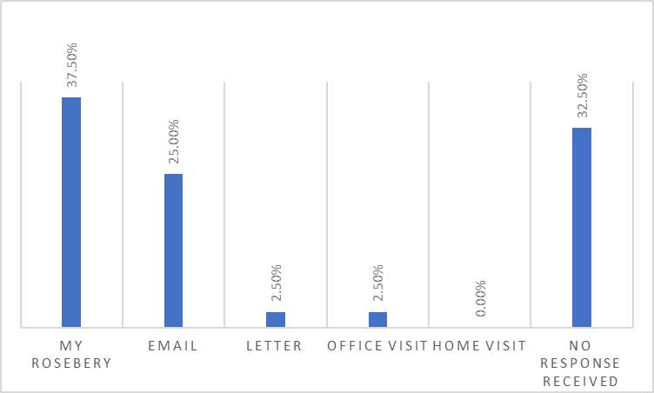

3.0 EASE OF REPORTING AND DEALING WITH YOUR QUERY

3.1 Was your question answered in full?

Options | Yes | No | N/A
Result | 55.00% (22) | 37.50% (15) | 7.50% (3)
June 2018 | 51.06% (24) | 31.91% (15) | 17.02% (8)

3.1 Do you feel the member of staff treated you with respect, were they friendly and polite?

Options | Yes | No | N/A
Result | 100% (25) | 0.00% | 15
June 2018 | 93.54% (29) | 6.45% (2) | 16

3.2 ‘My Rosebery’ tenant portal only – did you receive a response within five working days?

Options | Yes | No | N/A
Result | 94.44% (17) | 5.56% (1) | 22
June 2018 | N/A | N/A | N/A

3.3 Email only – did you receive a response within five working days?

Options | Yes | No | N/A
Result | 50.00% (8) | 50.00 (8) | 24
June 2018 | 61.54% (8) | 38.46% (5) | 34

3.4 Letter only – did you receive a response within five working days

Options | Yes | No | N/A
Result | 100% (1) | 0.00% | 39
June 2018 | 55.56% (5) | 44.44% (4) | 38

3.5 Office or home visit only – was the member of staff wearing an identification badge?

Options | Yes | No | N/A
Result | 100% (1) | 0.00% | 39
June 2018 | 100% (5) | 0.00% | 42

3.6 If you were advised you would receive information by My Rosebery, post or email, did you?

Options | Yes | No | N/A
Result | 75.00% (3) | 25.00% (1) | 36
June 2018 | 75.00% (3) | 25.00% (1) | 42

3.7 If you were advised that you would get a call back, did you?

Options | Yes – within given timeframe | Yes – outside time frame | No call back received | N/A
Result | 75% (9) | 0.00% | 3 | 28
June 2018 | 100.00% (1) | 0.00% (0) | N/A | 46

- HOW SATISFIED WERE YOU WITH YOUR RESPONSE & OVERALL EXPERIENCE?

Satisfaction Rating | Overall rating: 1 to 5  (1 being not satisfied,  5 being very satisfied) | Comparison: mystery shop in June 2018 –  service trend +/-
June 2019 | 3.5
June 2018 | 3

5.00 KEY FINDINGS

Mystery shoppers - feedback

During this mystery shop we have learnt the following:

Speed and quality of communication responses
5.1 Overall shoppers were impressed with the speed of responses received to their various queries. Apart from emails, most of their enquiries (90%+), were responded to within Rosebery’s service standard of five working days.

5.2 Out of the 16 emails enquiries raised only 50% were responded to within agreed target time. Disappointingly, some emails received no reply at all. Shoppers were most frustrated with the customer service received from Neighbourhood Team, due to lack of responses to their emails and quality of their responses
5.3 All shoppers agreed the Repairs Team responses were “amazing, efficient, thorough and clear”. However, it would be helpful when they are using ‘My Rosebery’, to mention their names.
5.4 Shoppers also agreed that responses received from the Income and Customer Experience Teams were clear and concise. However, more etiquette needs to be established with responses when using ‘My Rosebery’, there was no consistency in staff members stating their name and job title, most just offered their team name.

5.5. One shopper was initially disappointed when a trying to book a home visit to discuss an anti-social behaviour issue with their Neighbourhood Officer, despite the shopper offering several dates/times when they would be available. All were rejected, and the Neighbourhood Officer insisted that the shopper needed to come into the office, but offered no reason why. The shopper felt this was not the best customer service, but when the meeting was held this went very well.

Standard of customer service and quality of their experience
5.6 Shoppers agreed that once contact was made with Rosebery, the customer service provided by all staff met their expectations and all were treated with respect, friendly and polite.
5.7 Our Customer Experience and Repair Teams proved to be most popular in terms of their efficient and professional responses and where appropriate shoppers like how they expressed sympathy when they were unable to offer immediate assistance to their enquiries.

5.8 Shoppers reported that were inconsistences with receiving auto-acknowledgements from service teams’ mailboxes.
Knowledge and information provided by staff

5.8 The Income Team, particularly the Tenancy Sustainment Officers topped the chart for providing information and support to issues raised on rent and benefit queries. They were most helpful with issues relating to Universal Credit. The feedback received from shoppers that they were “very thorough and proactive, offering to assist with the completion of benefit application as well”.

5.9 Shoppers were impressed that the Income Team always made the point of giving their names and told do not hesitate to call back if they needed anything else.
5.10 There were very few negative experiences and generally all Rosebery staff were knowledgeable and able to assist with enquiry once direct contact had been made.

‘My Rosebery’ – shoppers were encouraged to use the tenant portal, to provide feedback on the ease of use and did this help to improve their experience

5.11 Shoppers offered positive feedback on the use of ‘My Rosebery’. Some used this for the first time as part of this shopping exercise and confirmed that they will continue to use as it offers more flexibility and suits people that work full-time.
5.12 Shoppers often received fast responses to their queries, that were clear, concise and the portal was easy to use. This is supported by the shopping results that out of the 18 enquiries that were raised on ‘My Rosebery’ 94% were responded to within five days. Only one query missed this target time, by 1 day.
- SERVICE IMPROVEMENT - ACTION PLAN

6.1 As a result of the findings from this mystery shopping exercise, Rosebery have agreed a service improvement action plan, to address the issue raised.
6.2 See Appendix 1, for Rosebery’s response and service improvement action plan.

